**Orphan Care and Support**

These services provide a permanent impact on the lives of vulnerable children by placing them in a safe, family environment through residential care, foster care and transitional living homes.

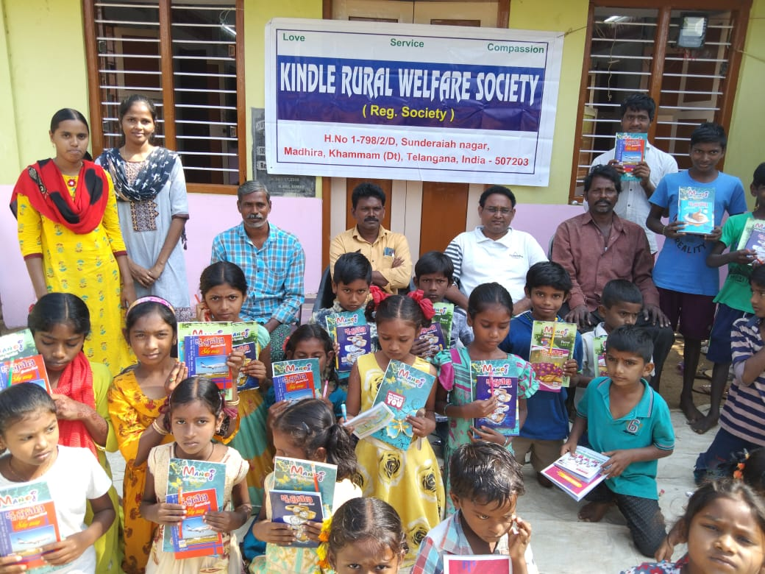

Women Empowerment

Our Organisation has been working for the upliftment and development of the Women’s from Scheduled Caste, Scheduled Tribes, and Backward Class Communities in Telangana and Andhra Pradesh, India.

Vocational Skills Training: The Vocational Training is provided such as Tailoring, Embroidery, Basket Making, Leaf plate making, and plastic/cane weaving for the women group participants.

In order to empower the women in the family and community Sewing Centres were established to give training to the women so that they may earn livelihood after training.  During training period the trainees save some money and receive some Loans towards starting their own enterprise that generates income for their livelihood.

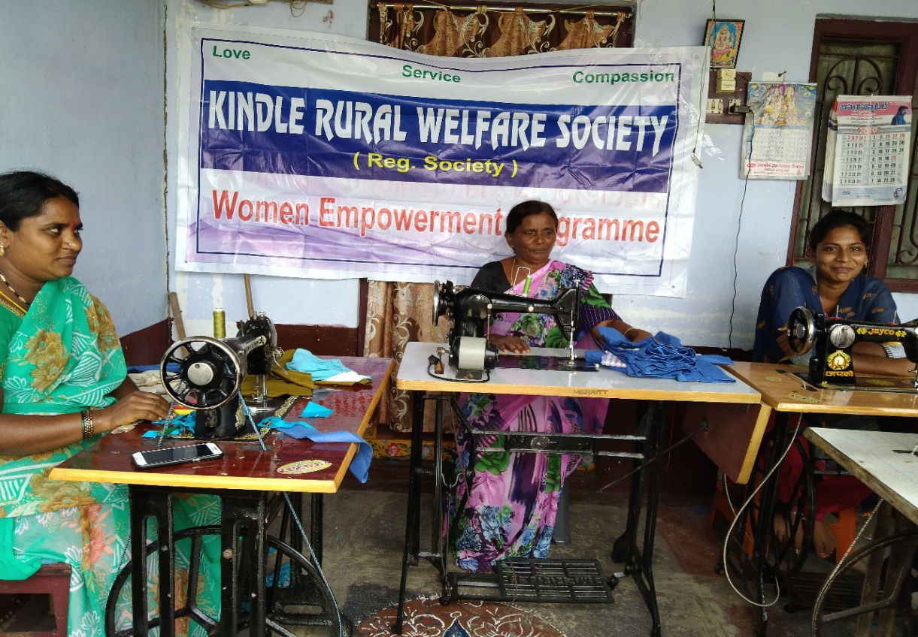

Ray of Hope   
“Learn & Earn”

Women Empowerment Program with a basic objective of creating alternative livelihood opportunities for the poor women   have sponsored a program under the banner “Learn and Earn” A Tailoring and lace making training program was initiated in August 2006, covering 10th and secondary saving group members in each group for a period of three months.

Women Empowerment Program with a focus to provide qualitative training has appointed Mrs.Marthamma Donakonda Village ,who has all the expertise and technically qualified in Tailoring and lace making. A marketing feasibility analysis has been made, and based on the market demands, wide range of partners, designs, colours and attractive models have been incorporated in the training.

The women who were working has agricultural laborers,which has always been seasonal were    living under the poverty line without much employment  opportunities earning a meager income which barely covered their minimum needs ,now with the opportunity provided to  “Learn and Earn “ have very happily getting trained, the women after the intensive three months training are provided with a of Rs 1000 for a group of three women to procure raw material. The women now are able to work independently are not just confined to producing the finished products are also very happily marketing in the local markets and are able to set a margin profit of Rs.1000 after clearing the loan amount.

**Youth welfare camps / Trainings**

Most of the youth excelled even in board examinations in distinctions and merits.  Later the continuation of further education was difficult because it was college levels, very much expensive.

The only alternative was to go back to his/her village which would repeat the same underprivileged conditions from where she/he was picked up.  Initially, our experience and studies reveal that the youth was not being (after completion of 10th class) accommodated/accilimicised as he/she grew in rich congenial atmosphere provided in the hostels.

When seriously thought of it, prayerfully we came up with a conclusion to start Youth Welfare Trainings that is giving technical training in respective skills.  Vocational skill training was given in typing, electrical works, motor driving, screen printing, computer training, basket making, sewing, tailoring and embroidery.

At the end of each course a recognized certificate was given along with subsidize equipment. Fortunately year by year the program excelled, many were able to earn themselves, their own livelihood and secured jobs.

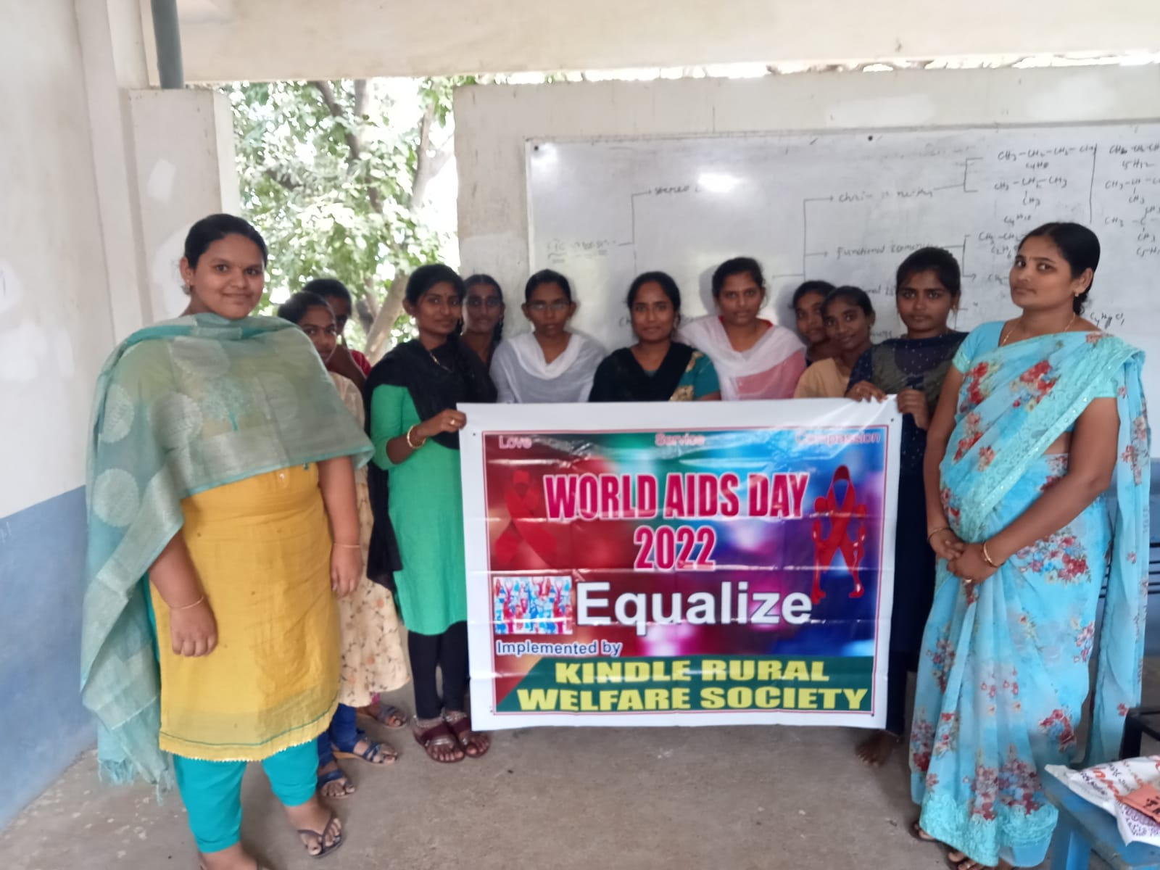

Integrated Community Development Program

Smile always Foundation are starting Integrated Community Development Program to serve the backward communities where the family is benefited rather than an individual child.  In this new approach the children receive opportunity to pursue their education while the parents are provided with an opportunity to develop new skills and participate in group activities and also inculcate habit of savings to develop them to reach sustainability. With a small beginning of children in this program it is also expanded further and the strength in this program. This is a family focus program.  These families are on the path of development to reach sustainability. The activity components of  ....

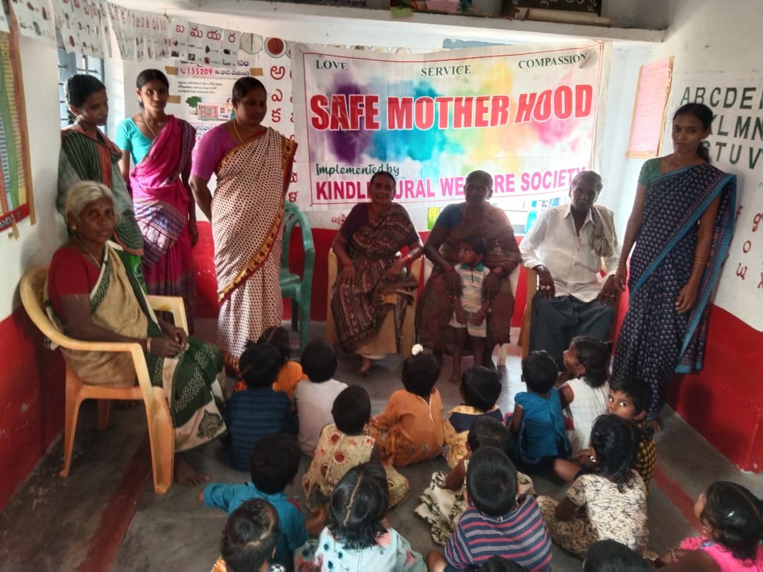

**Child Education**

The Integrated Community Development Program has been addressing the issue of Child education in the Communities.  As the Program is on the way towards sustainable development, this project plays a vital role.

* We provide school needs to identified children in Govt.Schools of our target areas.
* Provide extra coaching to children with the help of Tutors for better performance in their education.
* We offer training to children who are in higher classes to gain knowledge about life skills and develop English language skills.
* We organize meetings/seminars for all children and their parents to impart knowledge importance of education and understand about sustainable development.

**Child Development**

As the children are in higher classes and are growing there is need to develop the children to learn life skills and develop themselves to be a part in the process of child centered development. Training on life skills, English language  skills and meeting and seminar with parents to have more interaction and understanding about sustainable development.

* We offer life skills training for the children and to develop themselves.
* English language skills provided for children in higher classes.
* Meetings and seminar with parents to have more understanding about education.
* Awareness Programmes on importance of education.
* Assist School with teaching and learning materials.(Lab equipment )
* Important day’s celebration in all the target communities.
* Training to teachers.
* Formation of Children saving Bank.

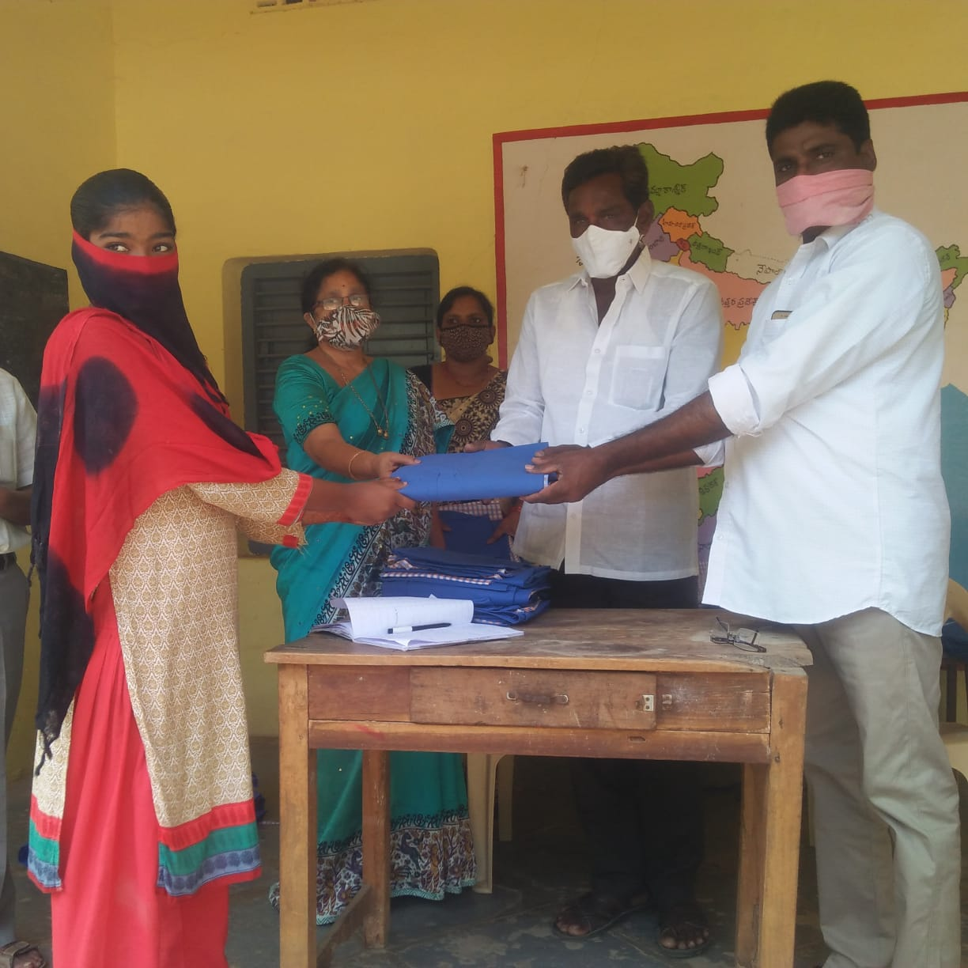

**Educate after school-underprivilege children in India**

This project will promote academic success, pay school fees, school kit to under privileged and to tribal children. This project will ensure the children education without drop-out. 280 child labour tribal children who have been mainstreamed also benefitted in this program. After school program, a safe space that support healthy social and emotional development, and promote academic success. Educating the under privileged ultimately will make a change for whole family and future generations.  
Challenge.

Our children need to have learning extended beyond the classrooms to receive the academic and social enrichment that is needed for them to do well in school and prepare for the future. Providing our programs in a safe and engaging environment is KRWS highest priority. We work in partnership with each community, school, and family to design the program that meets the specific needs. We employ an experienced leadership team and provide a healthy snack.

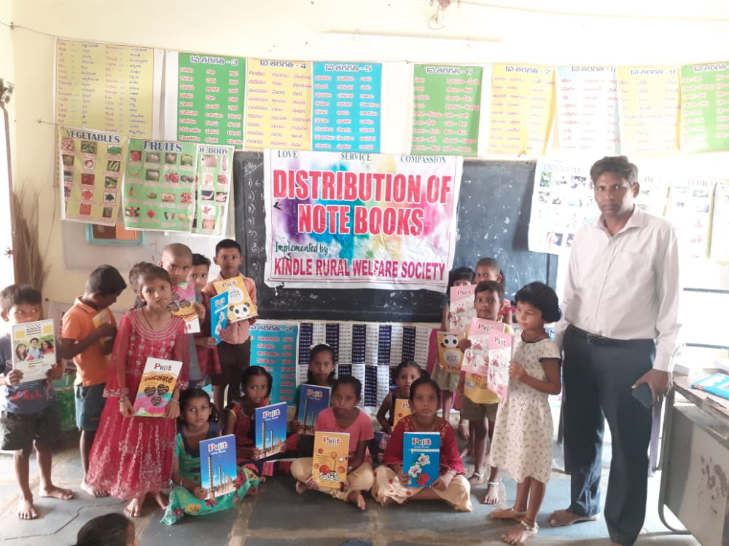

**Solution**  
After school education will help students realize their potential, supplement knowledge and to compensate skill gaps. KRWS makes sure 1,000 under privileged & tribal children remain active, motivated, and happy during their time away from school. Educating the under privileged ultimately will make a change for whole family and future generations.

**Long-term Impact**  
KRWS serves students from 1st grade through 12th grade and supports them to reach their full academic potential, prepare for college, and in turn give their time and talents back to their communities. We partner with parents, teachers, and the community to address the comprehensive education needs of our children and advocate for healthy families.

**Group Formation and Development**

Integrated Community Development Program strengthens the capacity of identified cluster group members in the communities. Cluster Group Formation encouraged, the Members learnt new skills and developed to realize their potential. The ICD Program at present has saving groups members.

* To develop new community groups consists of members in the target communities with the help of Area Development Organizers to create an opportunity of working together in groups and contribute in their own development.
* Conduct Need based basic literacy classes for saving group members by Community Facilitators to make them to learn basic literacy which needed for establishing their self reliance.
* We arrange skills training in different skills to group members to equip with new skills by program staff at all levels to build the capacity of the group members.
* We offered Vocation skills training in different skills to group members to learn new skills by training Instructors to learn new skills to earn their income.

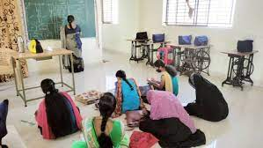

* **Need Based Literacy and Social Awareness**
* Literacy rate increased and 80% participants are neo-literates. The Integrated Community Development program conduct classes for groups Members. Through this activity the group’s members have received need based Literacy training and makes them aware of social stability. Community Facilitator is appointed for conducting daily classes while Field Staff oversee the overall program. 15-20 classes are conducted in a month in the evening time for one to two hours as per their convenience after they return from their work. The follow-up Courses will be undertaken for the Group Members who completed Primer Level courses.  
   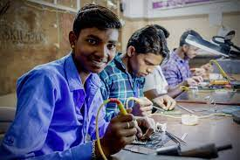

SKILL TRAING

The Group Members are trained and learnt new skills. ICDP will organize training for the members of new groups in

* Group Management and Leadership
* Simple accounting
* Kitchen gardening and training
* Poultry rearing and small business

Environmental awareness and social forestry and other skill development for group members and their family members. The training is continued for existing groups members.

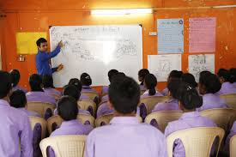

**Health Promotion**

Integrated Community Development Program has been undertaking health interventions for Health promotion in the communities. The health of the individual family members and thereby communities are slowly improving day by day following intervention of our program.  At present, there are more HIV infections every year. The trend in increasing infections poses a major threat to development in the communities. Therefore, ICD propose to undertake health promotion effectively integrating HIV prevention in the communities.

* Conduct Health awareness and health related interventions for people in the groups in particular and in the community in general by Health Promoter.
* Conduct HIV/AIDS awareness through related interventions for people in communities with a view to prevent and reverse HIV infections by Health workers.

Health standards improved for the Group Participants and frequency of illness reduced. Integrated Community Development program provides health education and health care of the group members.  Health Promoters are appointed to undertake this Activity. The emphasis is on Women and Child health and the program is for all the group participants and their immediate families. The health education program consists of 15 lessons as determined by the area needs following the PRA surveys.

It is proposed that 100 per cent of the participants know how to administer ORT. It is aimed that 20 Safe Delivery Attendants (SDA) receive training in conducting safe deliveries.

* Awareness on ATM (AIDS, T.B & Malaria)
* Training on health and hygiene to TOT’s
* Conduct awareness on ANC/PNC
* Awareness on Communicable Diseases
* Women health
* Prevention of Epidemics
* ORS, Diarrhea case management
* Organize programs to sensitize the community on Polio, Hepatitis B etc
* Providing demonstration classes for nutritional values among the community
* Awareness on TB
* Organizing Immunization Camps.
* Resource mobilization from local Government for low cost toilets.

**HIV/AIDS Awareness**

Over the years the HIV/AIDS epidemic has moved from urban to rural India and from high risk to general population. While working with community groups, and also undertaking HIV/AIDS project during the past year the ‘Smile always’ have had experience that the people in rural communities affected with this dread disease and they are ignorant of the disease. The primary concern is to halt and reverse the prevalence in our target communities next few years.  Condom promotion is incorporated in to prevention strategy.  
The following activities are undertaking in the communities.

* HIV/AIDS Awareness
* World AIDS Day observation
* Trainings for community leaders/Staff
* Education for Students
* Saving Group Leaders Sensitization on HIV/AIDS
* Life skills Education for Adolescent and Girls.

**Environmental Protection and Sanitation**

There are strong linkages between poverty and environment. Most of the target groups live in areas with limited natural resources and where the environment is badly degraded. This involves promoting good practices that will enhance the environment such as sanitation, tree plantation and avoiding practices that result in environmental degradation.

The Target Groups encouraged using and constructing sanitary latrines in their house premises. Subsidy is provided for the group members who come forward to construct sanitary latrines.

**Bavya’s Story :** **HAPPY TO HELP**

It was the first time I have seen Bavya the identified child of ICD program, sitting alone in the school, away from all her friends who were playing around with joyous mood. A Tear drop fallen from her eye clearly left the impact on her dry cheeks can speak many things about her inner heart. Desperate looks from her pale eyes shows that she is under very big depression. I heard much about her through our field officer. She was suffering with TOF, Pulmonary Atresia, and LPA Stenosis. She has to undergo an operation (Intra Cardiac Repair with pericardial valve conduit) as early as possible.

Bavya was just 7 years old. The parents of this child took her many places for the treatment. Some doctors said she is too young to withstand such an operation at this age. They asked the parents to see them when the child gets 10 years. Other doctors said it is a very expensive operation and requires a lot of money.

In this the parents also could not do anything to her. They approach the field staff and explained the matter. The operation costs was approximately Rs 5000. This amount cannot even imagine from her parents but the operation is a must as the child’s condition is becoming worst day by day. Her parents so depressed and worried about the future of this child.

A strong decision I made myself to do my best to help this little child, who is in need of her life to be extended.

Then we took the child to Dr. Praveen kumar and Dr. Naveen Reddy who were the surgeons and discussed the matter. After all the discussions the doctors decided to do operation and asked us to arrange money. Then we started thinking to get the source of getting money but it went very difficult for us.

We approached Government officials and given an application for the financial support, but it didn’t work out. The only thing we could do was praying. We sincerely prayed God to show us a way.   
  
When we were having different plans to raise money for her operation, God has a plan for this little child. This is what exactly happened in her life by the sincere efforts of ‘Smile always’. All our efforts were blessed and God opened a way through Government of India.

All the field staff and myself did our best in getting the arrangements for Bavya’s operation.

Finally by the grace of God the operation went successfully. “Man shall not live by bread alone but by the word of God” .

All are very happy and the joy we had... I just can’t explain. We all thanked God for the miracle He has done in Bavya’s life.

...Now Bavya is very active and leading normal life. She forgot the terrible time happened to her. Whenever I meet her she smiles at me with gratitude. I really appreciate the field staff for their commitment in attending this poor and needy child in right time.

- Mrs.Anusha  
President